Testing report 1

All fools day feedback

Technical testing

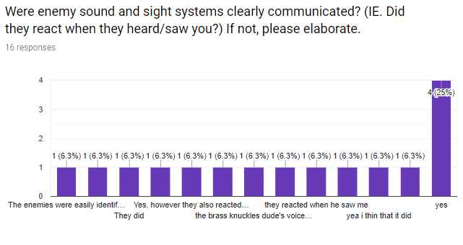

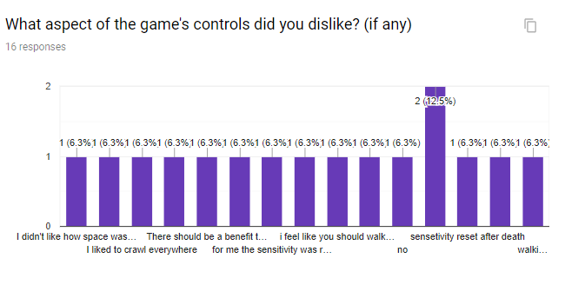

What was the worst part of the game's art?13 responses

No jiggle physics, shorts lemme down

some textures didn't match others

nothing

none

I enjoyed the art could have been a bit more color added to some places was very gray

It was a bit strange and it ddn't work with certain parts of the background

The death message is off-center.

design of zombie piles

The zombie arms in the piles

idk

The texture put into the surrounding buildings.

low quality models, but its in earl stages so to be expected

more detail on the streets

What was your least-favorite element of the game's sound/audio?11 responses

little loud on the pain train, nearly had a heart attack

nothing bad

nothing

Lack of music variety

It was a bit loud at parts

I thought the groan sound effect became a bit annoying after enough times; it would be better if there was more groan variety.

music

I was chill with it

the groan sound effect

I didn't have any issues with the audio.

I didn't listen to it

Focus testing

Were there any issues when you were playing? If so, please give examples.14 responses

i didnt have any issues playing the game

i got preeeeeeetty scared

no issues

I got out of bounds

a few out of bounds clips

hotboxes on some items. like clipping

I found it hard to know where to go.

Nope, other than the floor geometry on the slopes (which I avoided).

fell through floor

I was stuck inside a macho man

I managed to make myself invisible multiple times

The zombie didn't like to climb the sidewalk ledge when crawling.

not that i saw

camera view while crawling under

Usability testing results

What did you enjoy the most about the game?14 responses

the idea is really cool and i think that the game functions really good

Pain train... that was goooooood! :ok-hand:

i liked the hiding aspect along with a clear objective

Getting out of bounds by the pizza place

the ragdoll

The sneaking mechanic

I enjoy the concept, and it's been a while since I've played a dedicated sneaking game.

I enjoyed the gameplay and how easy it was to play

In level one, there were several paths (or seemed to be) for one objective, which was more-or-less ignored in level two; I liked how there were plenty of routes through the first level, though.

Fun and challenging

The idea that it is pure stealth

the ridiculous animations

Crawling around at high speeds.

crawling was cool

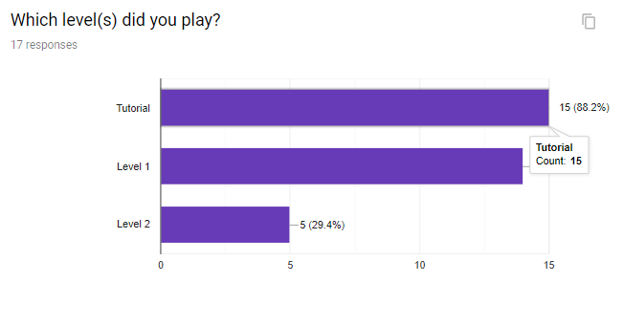

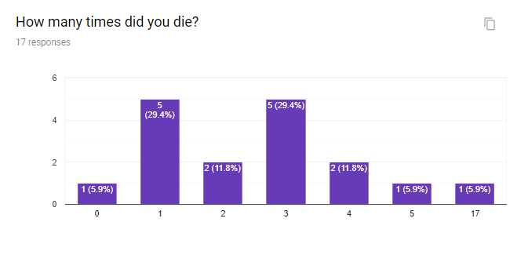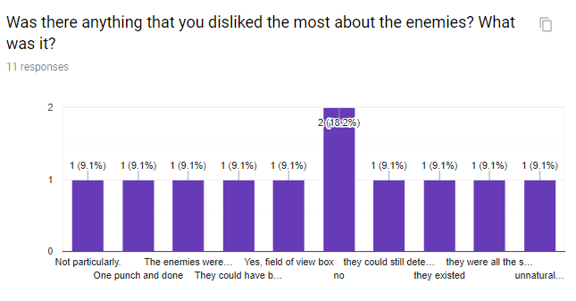

Playtesting feedback for Thursday game night.

Focus testing

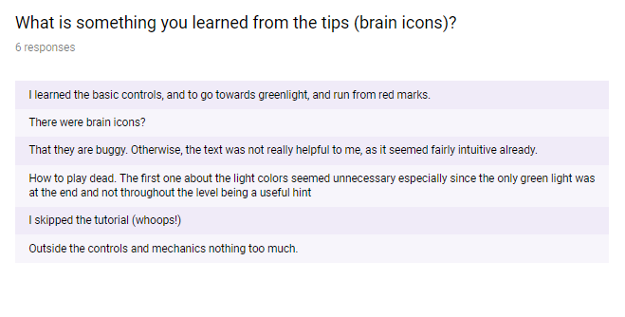

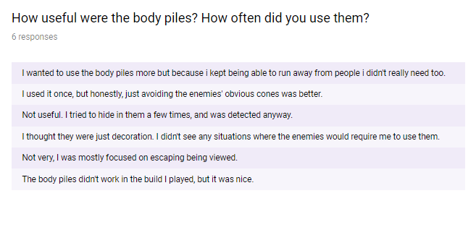

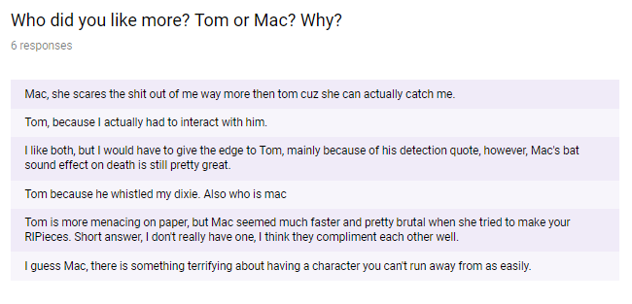

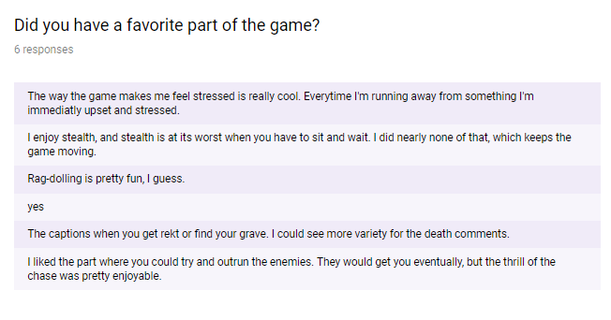

Technical Testing

